Experiment 1 — Installation of Hypervisors and initiation of VMs with an image file.
Install and configure an open-source hypervisor and create/instantiate a Virtual Machine (VM) using an existing image file. Demonstrate the successful installation and execution of the VM.

  - Tasks
• Install an open-source hypervisor such as Oracle VirtualBox
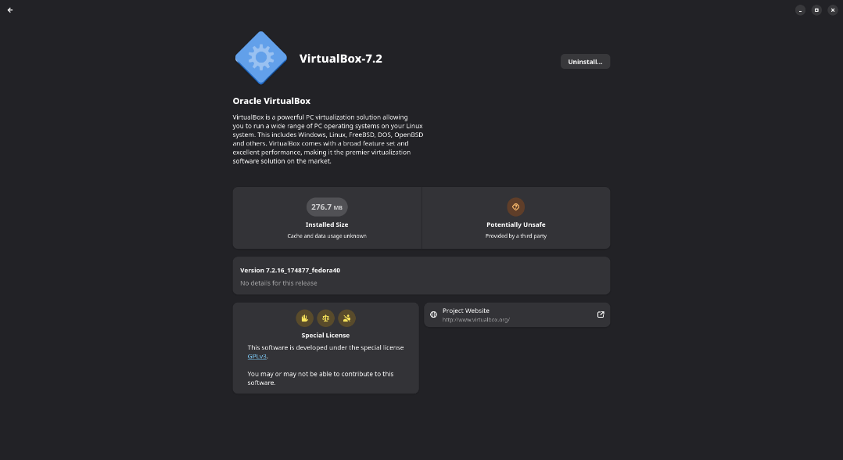
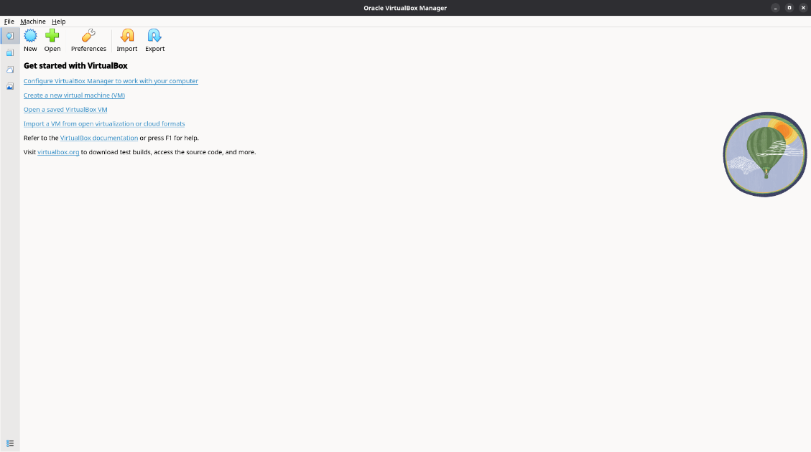

• Obtain a suitable VM image/ISO file.
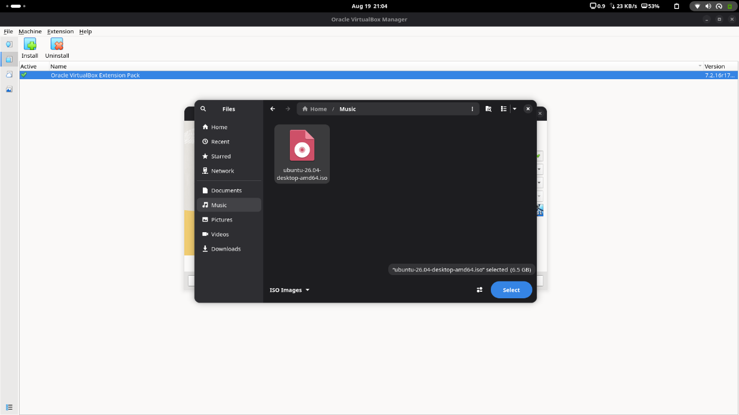
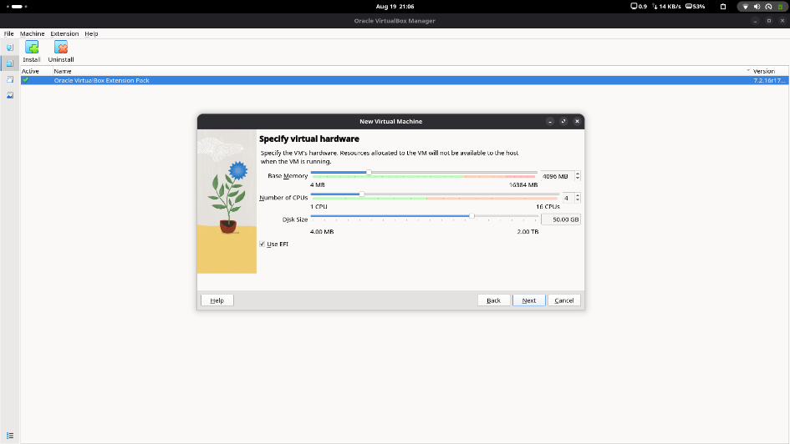
• Create a new VM using the hypervisor

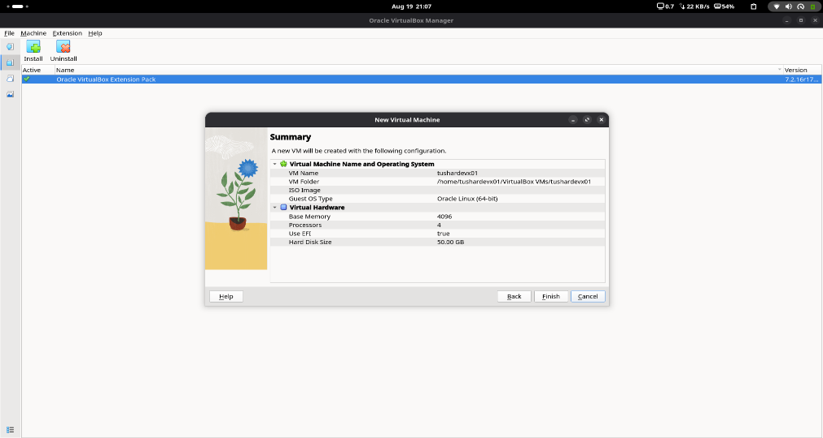

• Configure the VM's CPU, RAM, storage, and network.
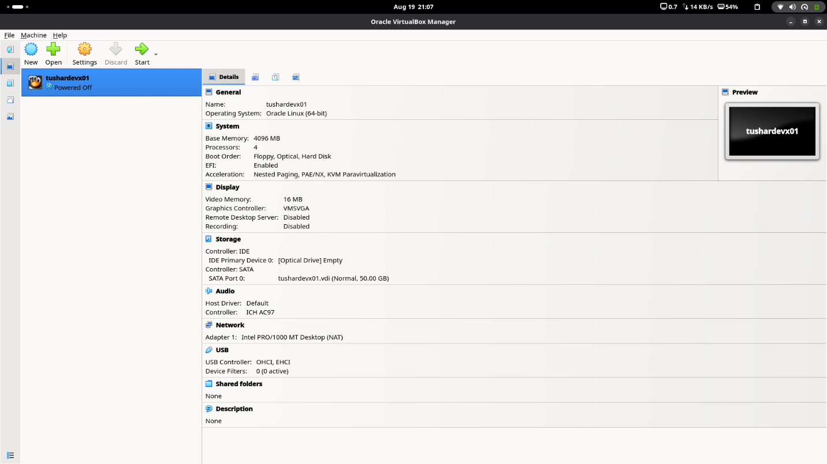

• Attach the image/ISO file to the VM.
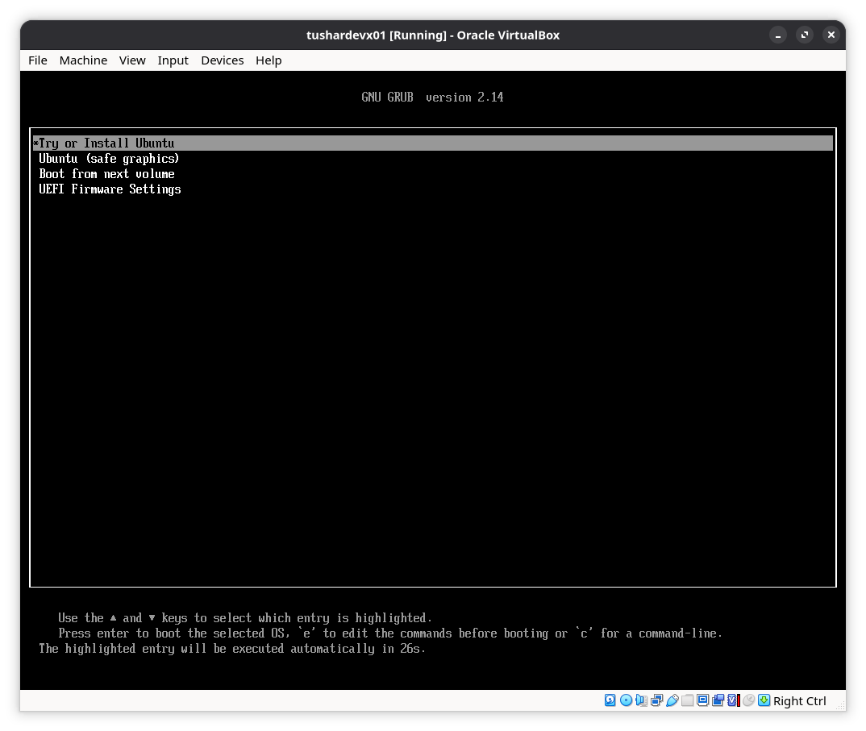
• Start and boot the VM
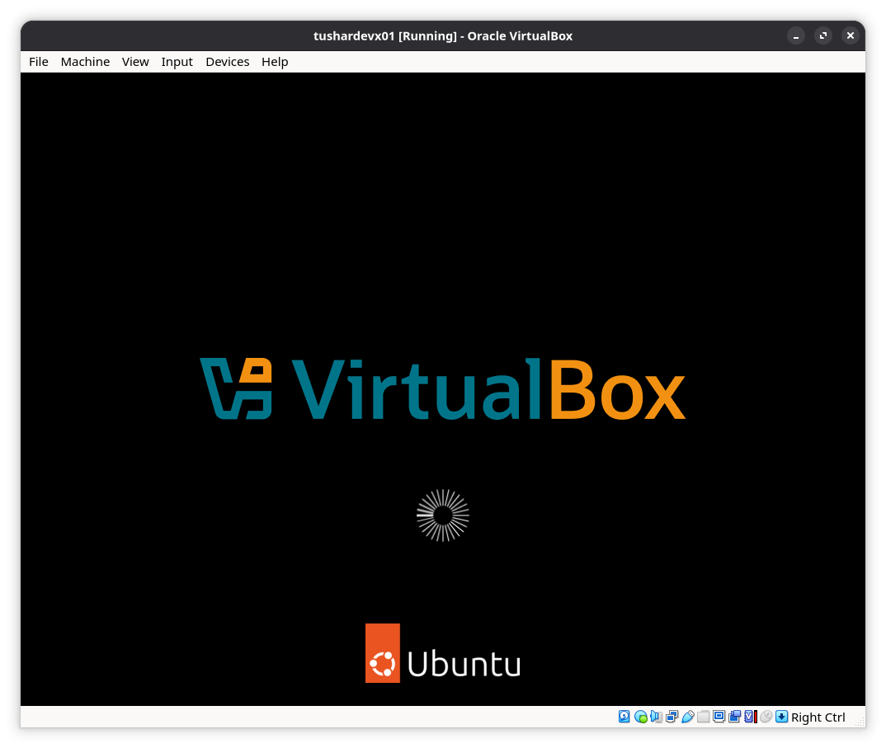
• Complete the guest OS installation, if required.
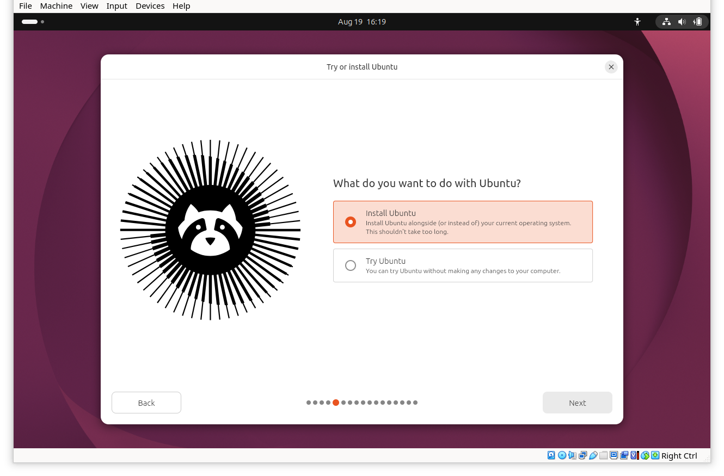

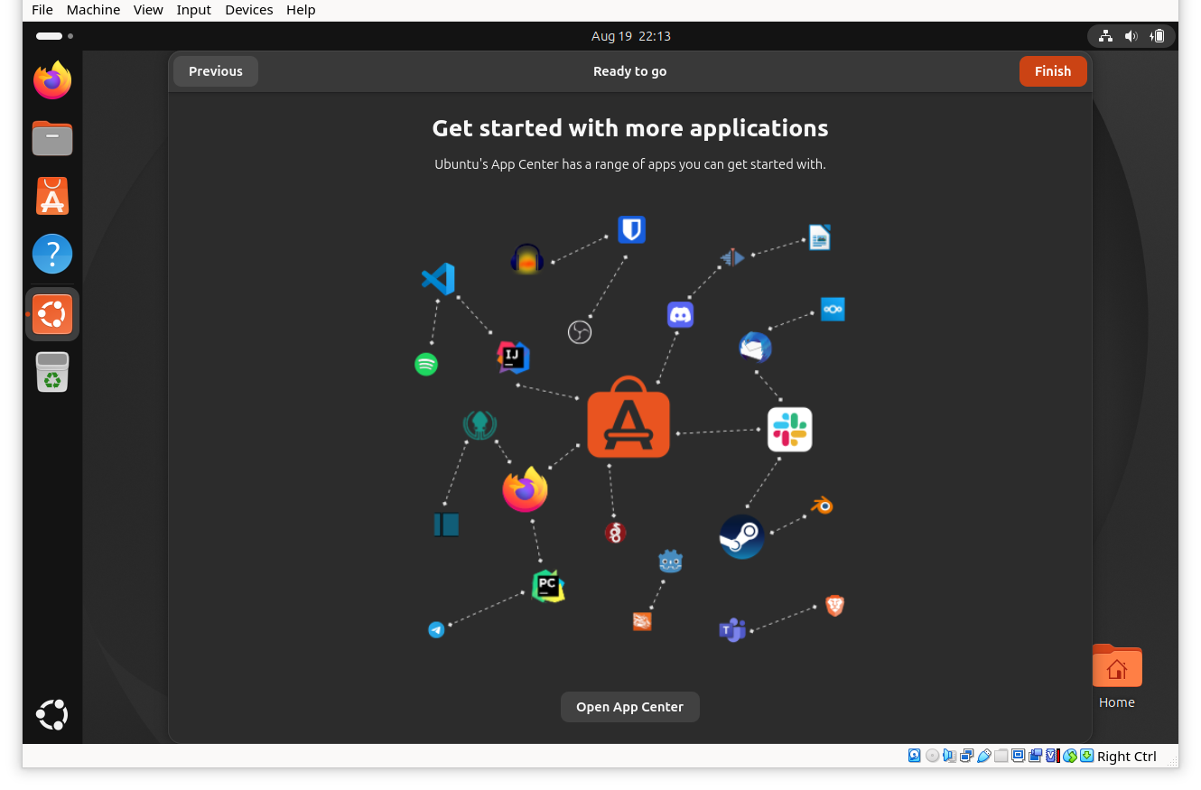
• Verify that the VM is running successfully.
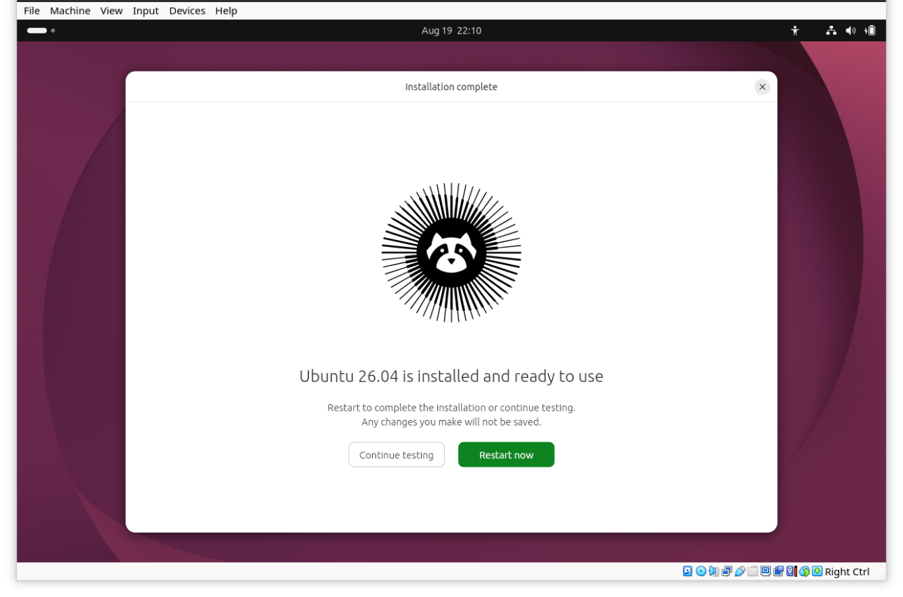
• Install the required build tools and Linux kernel headers
